**LECTURER PROFILE**

CURRICULUM VITAE

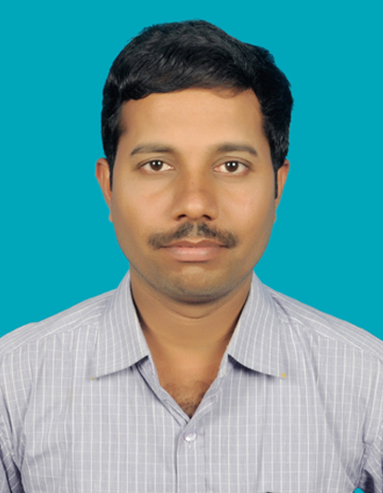

Name : KOTEESWARARAO OTTI

Designation : LECTURER IN HISTORY

Official Address : Govt. Degree College, Tekkali – 532201,

Srikakulam Dist, A.P.

Qualification : MA., B.Ed., A.P.SET, UGC NET

Date of Joining as a Lecturer : 21.05.2013

Address : BITIWADA VILL/POST

VEERAGHATTAM MANDAL

Srikakulam (Dist), A.P.

Cell: 8978849561,9398080983

Email ID: ottikoteeswararao@gmail.ccom

Academic Qualifications:

|  |  |  |  |  |
| --- | --- | --- | --- | --- |
| Qualification | University/Board | Year of Passing | % of Marks | Class Secured |
| M.A. | ANDHRA UNIVERSITY | MAY 2011 | 66% | FIRST |
| B.Ed. | Andhra University | OCTOBER 2008 | 61 | First |
| A.P.SET | Osmania University | 27-07-2012 |  |  |
| UGC NET | University Grants Commission | 29-06-2014 |  | First |

Research Experience: N/A

Awards and Recognitions:N/A

Membership of Professional / Academic societies: N/A

Seminars/Conferences/Workshop attended:

|  |  |  |  |  |
| --- | --- | --- | --- | --- |
| S. No | Title of Seminar | STATE LEVEL | Funded/organized by | Period |
| 1 | ANDHRA PRADESH HISTORY CONGRESS-43th | Paper presentation  విజయవాడ నగర అభివృద్ధిలో కనకదుర్గ దేవాలయం పాత్ర | SKVT COLLEGE RAJAHMUNDRY | 2019 JAN |
|  | ANDHRA PRADESH HISTORY CONGRESS-44th | AP | KVR GOVT DEGREE COLLEGE KURNOL | 2020 JAN |

Paper presented in National / International conference / Seminars:N/A

Faculty developments programmes attended:

|  |  |  |  |
| --- | --- | --- | --- |
| S No | Program Title | Organized / funded by | Period |
| 3 | Orientation Course | UGC- Human resource development centre,  Andhra university, Visakhapatnam | 14.07.2022 to 10.08.2022 |
| 5 | Faculty Development Programme in History | Commissionerate of Collegiate Education, Vijayawada, A.P. | 27.07.2020 to 31.07.2020 |
| 6 | Faculty development Programme in LMS Video & Pedagogy | Commissionerate of Collegiate Education, Vijayawada, A.P. | 03.08.2020 to 07.08.2020 |

**TEACHER ACHIEVEMENTS & PARTICIPATION:**

* Sri oO KoteeswararaoLecturer in History has qualified the APSET-2012 held on 27-07-2012.
* Sri oO KoteeswararaoLecturer in History has qualified the UGC NET-2014 held on 29-06-2014.
* Sri O Koteeswararao Lecturer in History participated 5 day faculty Development programme in LMS Video & Pedagogy organised by commissionerate of collegiate Education, Vijayawada, A.P. from03-08-2020 to 07-08-2020.
  + **Research Activity**
* The departmental faculty members regularly attend National, International Conferences /seminars and workshops on economic studies.